ECA1408-Embedded System Lab Experiments
Exp-1:
Program Code:

#define GAS_PIN A0 #define PIR_PIN 2
#define TRIG_PIN 8
#define ECHO_PIN 9
#define BUZZER 10
#define LED 11

void setup() { Serial.begin(9600);

pinMode(PIR_PIN, INPUT); pinMode(TRIG_PIN, OUTPUT); pinMode(ECHO_PIN, INPUT); pinMode(BUZZER, OUTPUT); pinMode(LED, OUTPUT);
}

void loop() {
int gas = analogRead(GAS_PIN); int motion = digitalRead(PIR_PIN);
digitalWrite(TRIG_PIN, LOW);
delayMicroseconds(2);

digitalWrite(TRIG_PIN, HIGH); delayMicroseconds(10);

digitalWrite(TRIG_PIN, LOW);

long duration = pulseIn(ECHO_PIN, HIGH); float distance = duration * 0.0343 / 2;

if (gas > 500) digitalWrite(BUZZER, HIGH); else
digitalWrite(BUZZER, LOW);

digitalWrite(LED, motion);

Serial.print("Gas Level: "); Serial.println(gas);

Serial.print("Motion: "); if (motion)
Serial.println("DETECTED"); else
Serial.println("NOT DETECTED");

Serial.print("Distance: "); Serial.print(distance, 1); Serial.println(" cm");
if (gas > 500) Serial.println("GAS ALERT!"); else if (motion)
Serial.println("OCCUPANCY DETECTED"); else
Serial.println("SYSTEM SAFE");

Serial.println(" ");
delay(1000);
}
Output:
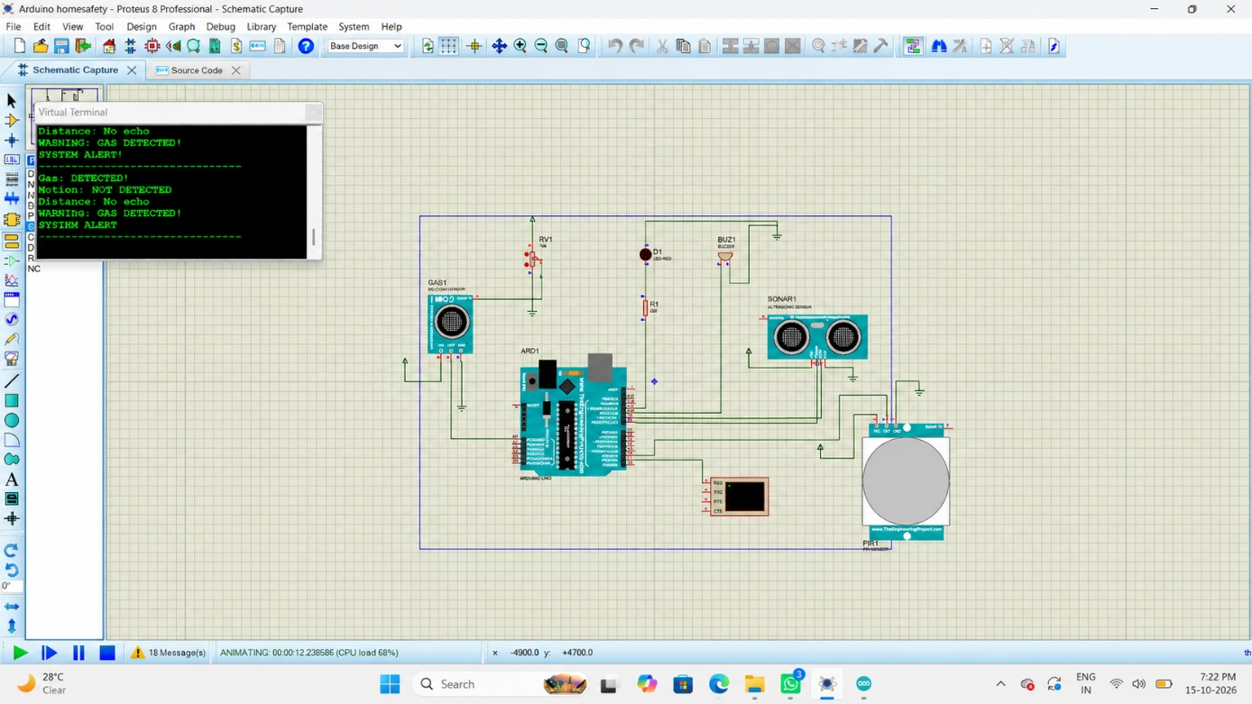

Exp-2:
Program Code:

enum TrafficState { STATE_NS_GREEN, STATE_NS_YELLOW, STATE_EW_GREEN, STATE_EW_YELLOW
};

TrafficState currentState = STATE_NS_GREEN;

// North-South traffic lights const int NS_RED_PIN = 2;
const int NS_YELLOW_PIN = 3; const int NS_GREEN_PIN = 4;

// East-West traffic lights const int EW_RED_PIN = 5;
const int EW_YELLOW_PIN = 6; const int EW_GREEN_PIN = 7;

void setup() { pinMode(NS_RED_PIN, OUTPUT);
pinMode(NS_YELLOW_PIN, OUTPUT); pinMode(NS_GREEN_PIN, OUTPUT);

pinMode(EW_RED_PIN, OUTPUT); pinMode(EW_YELLOW_PIN, OUTPUT); pinMode(EW_GREEN_PIN, OUTPUT);

Serial.begin(9600);
}

void allOff() { digitalWrite(NS_RED_PIN, LOW); digitalWrite(NS_YELLOW_PIN, LOW); digitalWrite(NS_GREEN_PIN, LOW);
digitalWrite(EW_RED_PIN, LOW); digitalWrite(EW_YELLOW_PIN, LOW); digitalWrite(EW_GREEN_PIN, LOW);
}

void enterState(TrafficState state) { allOff();

switch (state) {
case STATE_NS_GREEN: digitalWrite(NS_GREEN_PIN, HIGH); digitalWrite(EW_RED_PIN, HIGH); Serial.println("STATE S0: NS GREEN - EW RED"); break;

case STATE_NS_YELLOW: digitalWrite(NS_YELLOW_PIN, HIGH); digitalWrite(EW_RED_PIN, HIGH); Serial.println("STATE S1: NS YELLOW - EW RED");
break;

case STATE_EW_GREEN: digitalWrite(NS_RED_PIN, HIGH); digitalWrite(EW_GREEN_PIN, HIGH); Serial.println("STATE S2: NS RED - EW GREEN"); break;

case STATE_EW_YELLOW: digitalWrite(NS_RED_PIN, HIGH);
digitalWrite(EW_YELLOW_PIN, HIGH); Serial.println("STATE S3: NS RED - EW YELLOW");
break;
}
}

void loop() {
switch (currentState) {
case STATE_NS_GREEN: enterState(STATE_NS_GREEN); delay(10000);
currentState = STATE_NS_YELLOW; break;

case STATE_NS_YELLOW: enterState(STATE_NS_YELLOW); delay(3000);
currentState = STATE_EW_GREEN; break;

case STATE_EW_GREEN: enterState(STATE_EW_GREEN); delay(10000);
currentState = STATE_EW_YELLOW; break;

case STATE_EW_YELLOW: enterState(STATE_EW_YELLOW); delay(3000);
currentState = STATE_NS_GREEN;

break;
}
}
Output:

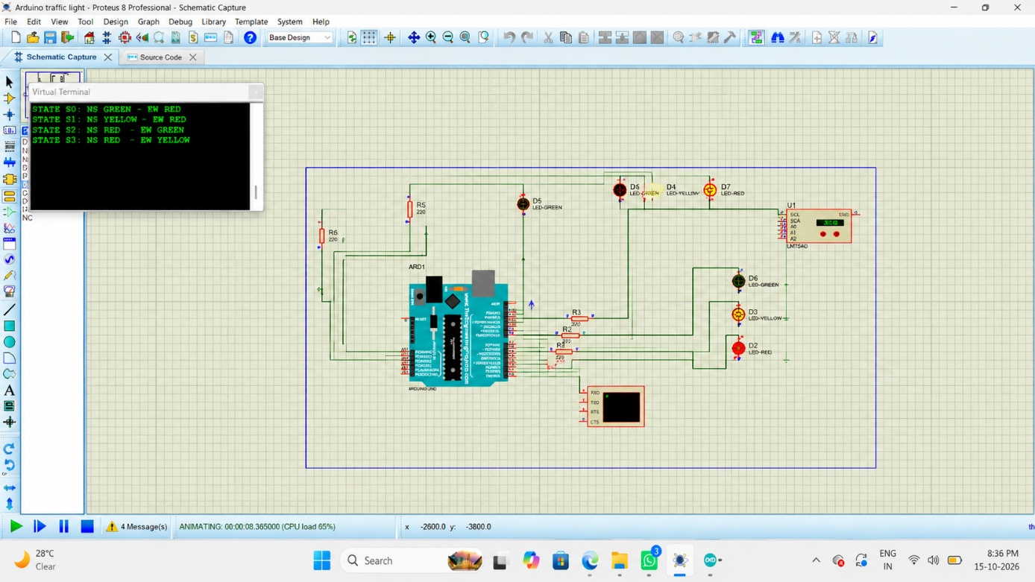

Exp-3:
Program Code:

#include <Wire.h>

#define LM75_ADDRESS 0x48 #define PULSE_PIN 8

unsigned long pulseCount = 0; unsigned long lastTempTime = 0; unsigned long lastBpmTime = 0;

int previousPulseState = LOW;

float readTemperature() {

Wire.beginTransmission(LM75_ADDRESS); Wire.write(0x00);
if (Wire.endTransmission() != 0) { return -999.0;
}

Wire.requestFrom(LM75_ADDRESS, 2);

if (Wire.available() >= 2) { byte msb = Wire.read(); byte lsb = Wire.read();

int16_t rawTemperature = (int16_t)(((uint16_t)msb << 8) | lsb);

// LM75 temperature is a signed 11-bit value rawTemperature >>= 5;

if (rawTemperature & 0x0400) { rawTemperature |= 0xF800;
}

return rawTemperature * 0.125;
}

return -999.0;
}

void setup() { Serial.begin(9600);

wire.begin(); pinMode(PULSE_PIN, INPUT);

Serial.println("I2C HEALTH MONITORING NODE");
Serial.println(" ");
}

void loop() {
unsigned long currentTime = millis();

// Count rising edges from the pulse sensor
int currentPulseState = digitalRead(PULSE_PIN);

if (currentPulseState == HIGH && previousPulseState == LOW) { pulseCount++;
}

previousPulseState = currentPulseState;

// Read temperature every 1 second
if (currentTime - lastTempTime >= 1000) { lastTempTime = currentTime;

float temperature = readTemperature();

Serial.print("Temperature: ");

if (temperature > -100) { Serial.print(temperature, 1);

Serial.println(" C");
} else {
Serial.println("Sensor Error");
}
}

// Calculate pulse rate every 5 seconds
if (currentTime - lastBpmTime >= 5000) { lastBpmTime = currentTime;

float bpm = pulseCount * 12.0;

Serial.print("Pulse Rate: "); Serial.print(bpm, 0); Serial.println(" BPM");
Serial.println(" ");

pulseCount = 0;
}
}

Output:

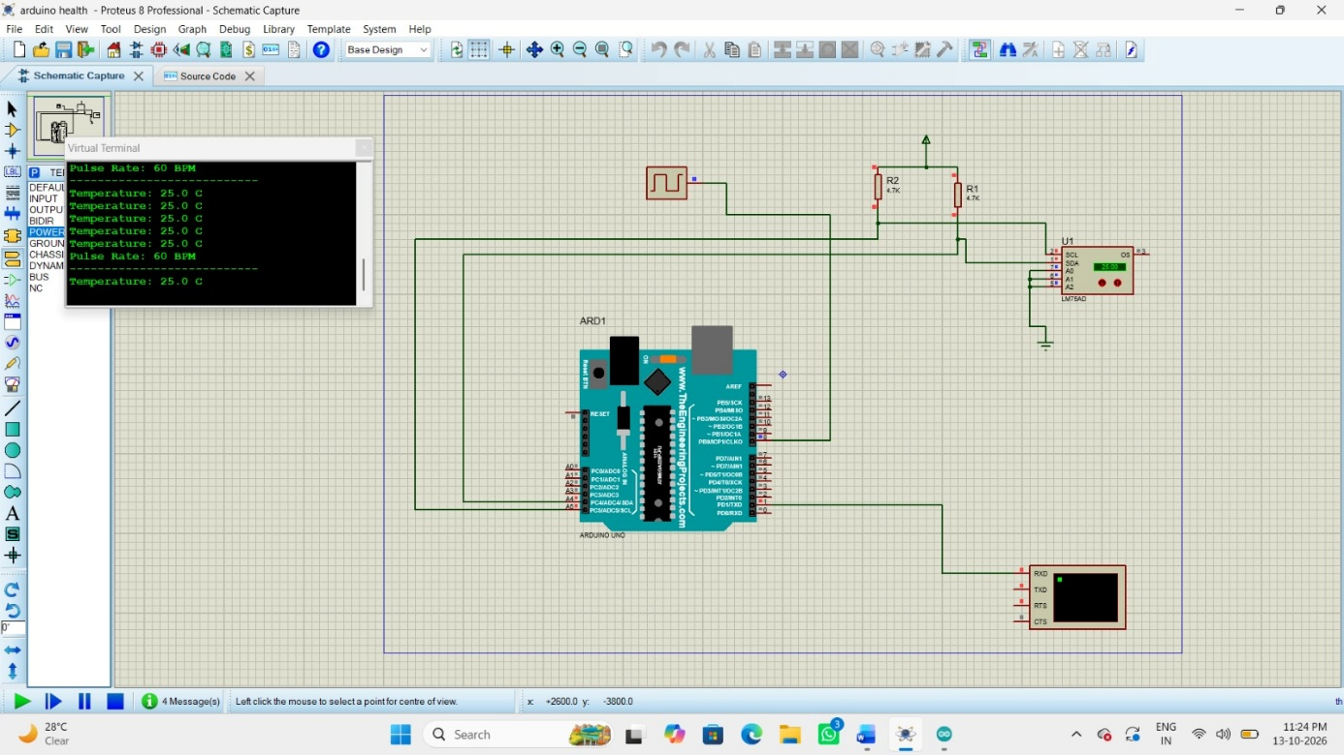

Exp-6:
Program Code:

#define TEMP A0 #define FAN 8

volatile byte pwm = 0; volatile byte count = 0;

ISR(TIMER1_COMPA_vect) {
count++;

if (count >= 100) { count = 0;
}

digitalWrite(FAN, count < pwm);
}
void setup() { Serial.begin(9600); pinMode(FAN, OUTPUT);

noInterrupts();

TCCR1A = 0;
TCCR1B = (1 << WGM12) | (1 << CS11); OCR1A = 199;
TIMSK1 = (1 << OCIE1A);

interrupts();
}

void loop() {
int adc = analogRead(TEMP);

// For an LM35 sensor powered at 5 V float temp = adc * 500.0 / 1023.0;

if (temp < 25) { pwm = 0;
} else if (temp < 30) { pwm = 30;
} else if (temp < 35) { pwm = 60;
} else { pwm = 90;
}

Serial.print("Temperature: "); Serial.print(temp, 1); Serial.print(" C PWM: "); Serial.print(pwm); Serial.println("%");

delay(1000);
}
Output:

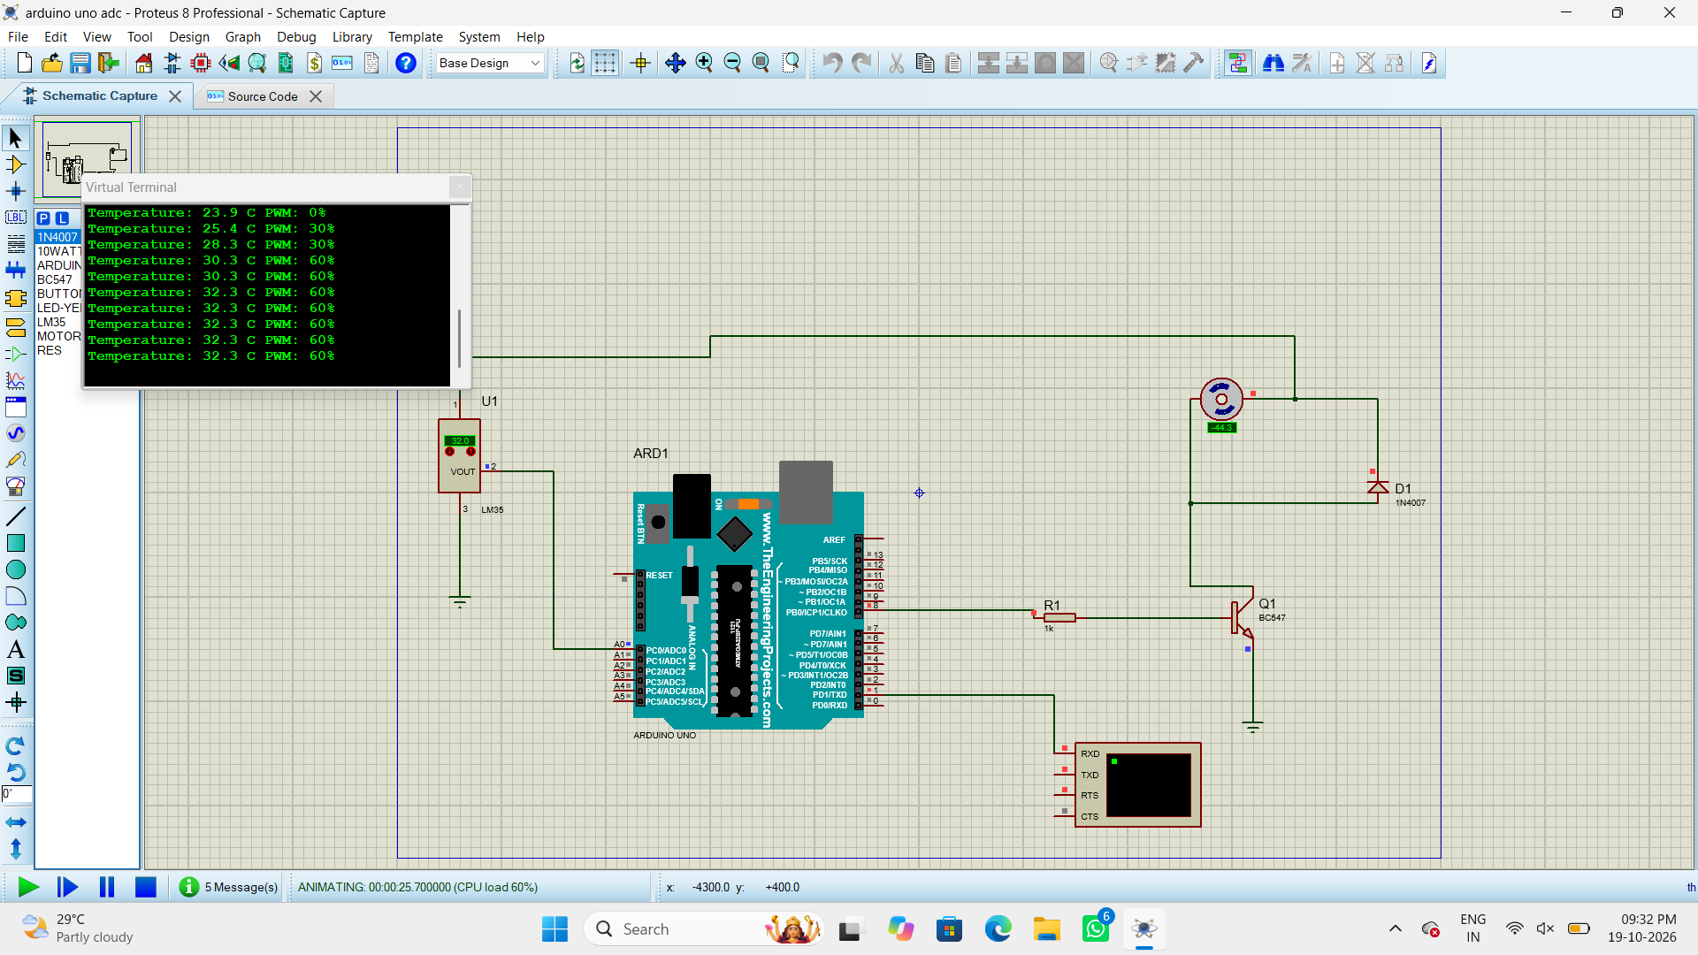

Exp-10:
Program Code:

#include <systemc.h> #include <iostream>

using namespace sc_core; using
namespace std;

SC_MODULE(ClockExample)
{
sc_in<bool> clk;

void process()
{
while (true)
{
wait();
cout << "Time: " << sc_time_stamp()
<< " - Clock Triggered" << endl;
}
}

SC_CTOR(ClockExample)
{
SC_THREAD(process); sensitive << clk.pos();
}
};

int sc_main(int argc, char* argv[])
{
sc_clock clock("clock", 1, SC_NS);

ClockExample module("module"); module.clk(clock);

sc_start(5, SC_NS);

return 0;
}
Output:

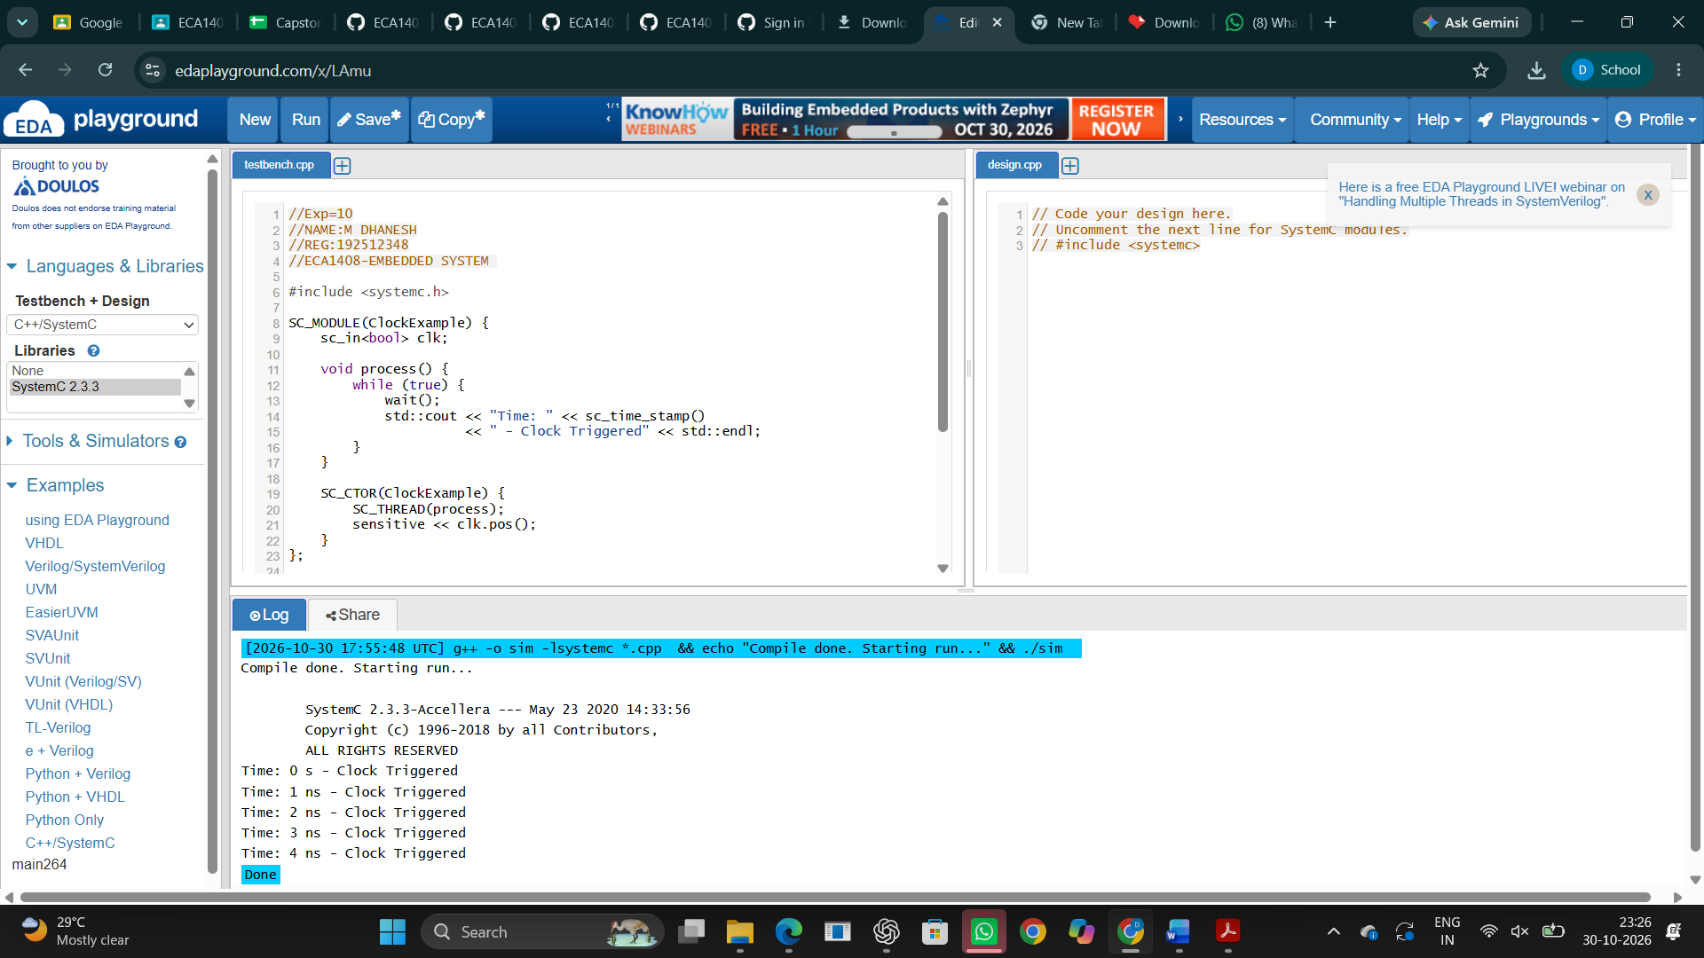

Exp-11:
Program Code:

#include <systemc> #include <tlm>
#include <tlm_utils/simple_initiator_socket.h> #include <tlm_utils/simple_target_socket.h>

using namespace sc_core; using namespace tlm; using namespace std;

// Target Module
struct Target : sc_module
{

tlm_utils::simple_target_socket<Target> socket;

SC_CTOR(Target) : socket("socket")
{
socket.register_b_transport(this, &Target::b_transport);
}

void b_transport(tlm_generic_payload& trans, sc_time& delay)
{
int* data = reinterpret_cast<int*>(trans.get_data_ptr());

cout << "Target received: " << *data << endl;

delay += sc_time(10, SC_NS);
}
};

// Initiator Module
struct Initiator : sc_module
{
tlm_utils::simple_initiator_socket<Initiator> socket;

SC_CTOR(Initiator) : socket("socket")
{
SC_THREAD(thread_process);
}

void thread_process()
{
tlm_generic_payload trans;

sc_time delay = SC_ZERO_TIME;

int data = 555;

trans.set_command(TLM_WRITE_COMMAND); trans.set_data_ptr(
reinterpret_cast<unsigned char*>(&data)
);
trans.set_data_length(sizeof(data));

cout << "Initiator sending: " << data << endl;

socket->b_transport(trans, delay);

wait(delay);
}
};

// Main Function
int sc_main(int argc, char* argv[])
{
Initiator initiator("initiator"); Target target("target");

initiator.socket.bind(target.socket);

sc_start();

return 0;
}
Output:

